**AI LAB ASSIGNMENT 9.3:**

M.VARSHITHA

HALLTICKET NO:2403A52342

**TASK 1:**

**write a python program using functions to return sum of even and odd numbers in the given list**

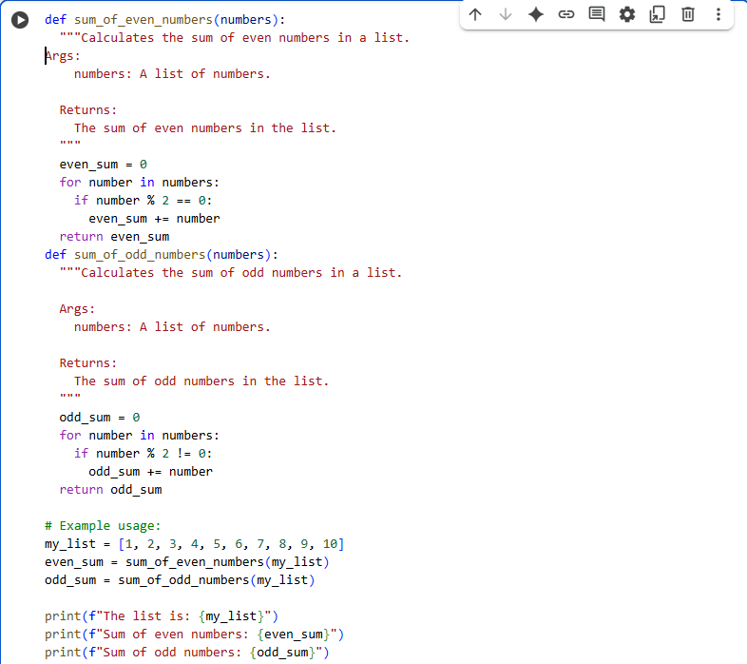

**OUTPUT:**

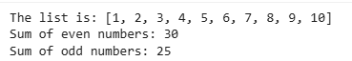

**TASK 2:**

**• Write python program for sru_student class with attributes like name, roll no., hostel_status and fee_update method and display_details method. Write comments manually for each line/code block..add inline comments explaining each line**

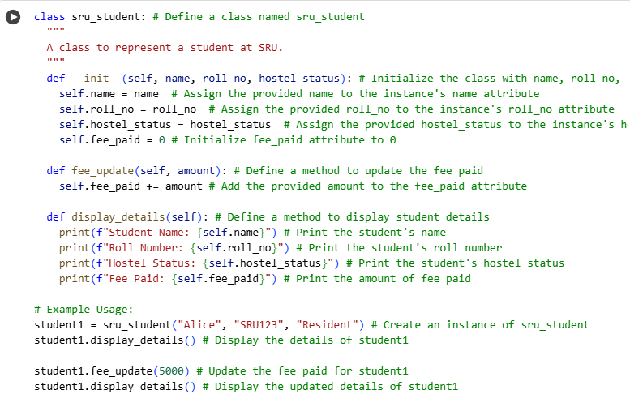

**OUTPUT:**

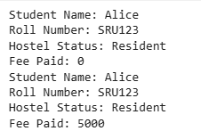

**TASK 3:**

**• Write a Python script with 3–4 functions (e.g., calculator: add, subtract, multiply, divide).Incorporate docstrings**

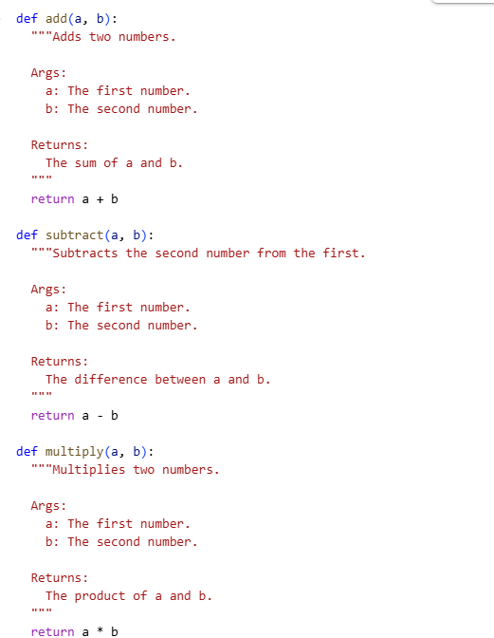

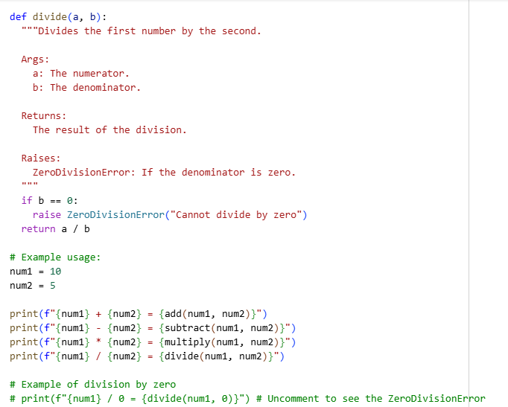

**OUTPUT:**

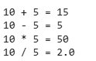

**EXPLANATION OF ALL CODES:**

